
Katz Group Canada Limited
5965 Coopers Avenue
Mississauga, Ontario
L4Z 1R9, Canada

September 3, 2003

Dear Mr. Mike Salvati, JD Edwards

Re: Request for Proposal, Retail Supply Chain Management Systems

Attached, please find the Request for Proposal (RFP) for a Retail Supply Chain Management software suite for Katz Group Canada Ltd. This request has a number of sections for you to complete, and instructions for proposal submission.
Please respond to all sections and attach all pertinent documentation.

Response to this RFP is requested by email and hard copy. The emailed response must be received by 5:00pm, Wednesday, September 24, 2003 EST. Hard copies are to be received by Friday, September 26, 2003.

A self-assessment is to be performed using the attached file (Katz Requirements.xls) and the instructions contained therein.

To confirm your intent to respond to this RFP, please sign the Statement of Confidentiality in Appendix C and fax a copy to myself at 905-502-5618, by 5:00 PM on Friday, September 5, 2003.

Katz Group Canada will hold an information session for all vendors participating. This session will be held from 9:00 AM to 12:00 PM on Friday, September 12, 2003 at the:

Toronto Airport Hilton
Ontario Room
5875 Airport Road
Mississauga, Ontario

From Pearson International Airport: Complimentary shuttle

Coming from East: Take Highway 401 Westbound to Highway 409 Westbound, exit on Airport Rd. and turn Left. The Hilton Toronto Airport Hotel is on your Left through the second set of lights.

Coming from West: Take Highway 401 Eastbound to Highway 427 north, exit on Dixon Rd. and turn Left. The Hilton Toronto Airport Hotel is on your Right after the Esso gas station.

Please contact me for answers to any questions. Thank you.

Sincerely,

Mr. Alan Pinington
IBM Business Consulting Services
Selection Project Consultant
alp@ca.ibm.com
Phone: 905-316-3322
Fax: 905-502-5618



Request for Proposal
Retail Supply Chain Management Systems
September 3rd, 2003

CONFIDENTIALITY NOTICE
The following document is intended only for use in the Request for Proposal process. This report includes information which is privileged and confidential. This report must be handled as a confidential document within your organization. No part of this document may be distributed, reproduced, quoted from, or discussed outside your organization without written approval from Katz Group Canada Limited.

Table of Contents
1.0 Overview 5
1.1 Purpose of the RFP 5
1.2 About Katz Group Canada Ltd. 5
1.3 Strategic Objective 6
1.4 Why Retail Supply Chain Management Systems? 6
1.5 Project Scope 6
1.6 Key Business Differentiators 7
1.7 Organization Overview 8
1.8 Key Data 8
1.9 Systems Considerations 9
1.10 IBM’s Role in the Selection Process 9
2.0 Response Instructions 10
2.1 Inquiries 10
2.2 Method of Submission 11
2.3 Selection Process Schedule 12
2.4 Selection Criteria 12
2.5 Confidentiality 13
2.6 Acceptance of Responses 13
2.7 Preparation Cost 13
2.8 Attachments & Appendices Summary 13
3.0 Vendor Information 16
3.1 General Vendor Details 16
3.2 Similar Industry References 18
3.3 Product Information 20
3.4 Implementation Considerations 23
3.5 Product Support 24
4.0 Product Technology 26
4.1 Technical Environment 26
4.2 Integration and Interfaces 32
4.3 Product Limitations 34
4.4 Management Tools 35
5.0 Product and Service Costs 37
5.1 Agreements 37
5.2 Product Costs 37
5.3 Options 39
6.0 Functional Requirements 40
6.1 Retail Supply Chain Management Requirements 40
6.2 Additional Systems Capabilities 40
Appendices 41
Appendix A: Katz Store Map and Head Office Locations 41
Appendix B: Present Application Systems Overview 43
Appendix C: Statement of Confidentiality 44
Appendix D: Key Business Capabilities & Probable Business Releases 45
Appendix D: To-Be Process Maps Based on Leading Practices 46

1.0 Overview

1.1 Purpose of the RFP

The purpose of this Request for Proposal (RFP) is to solicit vendor submissions for evaluation of retail supply chain management systems. This RFP is being submitted to five software vendors.

1.2 About Katz Group Canada Ltd.

Katz Group Canada Limited (herein referred to as Katz) is Canada’s leading integrated retail pharmacy network. With over 1,500 corporate, franchise and independent pharmacies, Katz has more pharmacies across Canada than any other retail pharmacy network.

Many of Canada’s most trusted and recognized pharmacy banners are members of the Katz network. Banners include:
- Pharmx Rexall Drug Stores Ltd.
- Pharma Plus Drugmarts Ltd.
- Medicine Shoppe Canada Inc.
- Guardian—Drug Trading Company Limited
- I.D.A.—Drug Trading Company Limited
- Herbies for Drug and Food/Payless
- MEDITrust—Canada's only national mail order pharmacy

Katz’s mission, through its PharmAssist™ brand and program, is to maintain and foster excellence in pharmacy care and services within its network.

In addition to pharmacy banners, Katz holdings include Drug Trading Company Limited, Canada’s oldest and largest pharmacy retail cooperative, D.C. Labs Limited (product packaging/manufacturing) and ProPharm Limited (pharmacy systems software/hardware development and services).

Katz Group Canada Ltd. is a division of Katz Group Inc. Based in Edmonton, Katz Group Inc. is a privately held company owned by majority shareholder Mr. Daryl Katz. In addition to Canadian holdings, Katz Group Inc. owns and operates Drug Emporium and Snyders Drug Stores in the United States.

1.3 Strategic Objective

Katz’s overall business strategy is:

Our corporate stores will be the pharmacy of choice for the time-constrained female shopper seeking everyday health solutions, basics and seasonal merchandise for herself, her home and her family. We will be conveniently located, community stores that will provide current and innovative merchandise in an efficient, friendly and appealing shopping environment.

1.4 Why Retail Supply Chain Management Systems?

Process improvements enabled by new merchandising and supply chain systems are required to enable Katz to achieve its business strategy and respond to anticipated consumer demand.

Katz needs to deliver superior customer service and added value through the effective flow of physical goods, visibility of associated information and management of the entire business. Systems and processes must enable efficient merchandise and inventory planning within the extended supply chain. Performance measurement, transactional and decision support capabilities must assist in revenue enhancement and cost containment efforts.

Katz’s supply chain initiative has mandated the selection of a retail supply chain management system for Katz. The selection phase follows a strategic supply chain assessment completed in July 2003. The recommendations from the study specified a comprehensive road map that requires implementation of a corporate retail supply chain management system.

1.5 Project Scope

The scope of this system selection project is focused predominantly on the business requirements of Katz’s head office and the corporate stores but also considers those of the independent store network. The intent is to find one cost-effective applications architecture (i.e. one solution or one set of solutions) that will meet the requirements of the complete Katz retail organization.

Vendors are asked to submit proposals on the best implementation strategy for their respective solutions given the organizational model currently deployed in Canada. Again, while this initiative is focused on Katz’s Canadian business, Katz’s expectations are that the selected system will be eventually rolled out to Katz’s US operations.

1.6 Key Business Differentiators

Key functional requirements were identified through cross-functional workshops. Katz’s key business differentiators include:

Multi-banner organization
- Katz operates multiple banners, multiple store sizes (200 to 15,000 sq feet) with regional and location-specific variances in the merchandise mix. Katz must be able to cluster stores based on demand or by user defined criteria. Katz needs the ability to plan merchandise at a store department or category based on unique demand. The objective is to optimize store sales through store specific assortment and planograms.

Entrepreneurial spirit
- Katz operates as an entrepreneurial organization which results in a need to support rapid change. This requires a system that can be rapidly reconfigured with a minimal time and effort.

Usage of distribution channel
- The acquisition of the majority of Katz product is outsourced to multiple distributors. Katz has a requirement to increase control and visibility over its supply chain processes requiring systems with the ability to collaborate with external systems (i.e. forecasting, product planning, replenishment orders, invoices, visibility of external inventory, allocation, etc.).

Proprietary POS systems in stores
- Katz operates over 300 corporate stores which have proprietary point of sale (Auto-Star) and dispensary systems (Nexxsys). Katz requires an interface to synchronize data (item, price, sales, inventory, replenishment orders, etc.) between both systems.

Variety of product identifier tags
- Product identification varies by commodity type and includes item #’s, UPC #’s, PLU #’s, DIN and Pack size. The system must be able to support these identification types. This is due to the fact that Katz sells drug, grocery and sundry items.

Multiple units of measure
- Planning and execution modules will need to operate using multiple units of measures. Katz sells and inventories items by units, weight and volume.

1.7 Organization Overview

- Company Locations Affected by New Systems (see Appendix A)

- Multi-currency Requirements
Katz buys, sells and reports in multiple currencies, primarily Canadian and U.S. dollars, although Yen and the Euro may be required in the future.

- Multi-language Requirements
Katz requires system screens and reports to be available in multiple languages, with the ability for the user to set the language of preference. English and French are the official languages of Canada and must be supported.

- Customer Channels
- Stores (Retail Drug, grocery)
- Mail Order
- Web based

- Regulatory Requirements
- Health Canada
- Provincial Health Ministries
- Provincial Colleges of Pharmacists
- Personal Information Protection and Electronic Documents Act (Bill C6)

1.8 Key Data

Consolidated Sales | CD$4.2 Billion
Number of corporate stores | 310
Number of independent stores | 1264
Number of franchise stores | 70
Average lines per store replenishment order | 8
Number of vendors | 3,150
Rx | 150
CPG | 3,000
Monthly purchase orders | 270,000
Number of active items | 119,000
Rx | 9,000
CPG | 110,000

These figures represent current performance. Future growth may result in increases of between 20% and 50%.

1.9 Systems Considerations

In the full implementation, there will be approximately 400 corporate users (head office), with about 200 concurrent sessions. The potential for store connections needs to be taken into consideration.

1.10 IBM’s Role in the Selection Process

While IBM is an active participant in the development of this RFP and overall facilitation of the selection process, the final selection decision will be made solely by the Katz selection team.

2.0 Response Instructions

2.1 Inquiries

Efforts have been made to ensure that this RFP document provides adequate information for you to base your responses on. However, should you have any questions or require further clarification, please direct inquiries to:

Mr. Alan Pinington
IBM Business Consulting Services
Selection Project Consultant
alp@ca.ibm.com
Phone: 905-316-3322
Fax: 905-502-5618

Please do not contact Katz directly regarding this RFP. IBM is the sole contact per Katz’s request, to provide each vendor with an efficient and consistent level of service. IBM will ensure any and all questions regarding the selection process and RFP are answered expeditiously. IBM will also facilitate responses for any additional Katz information that may not be contained herein. Although IBM is the main contact point, Katz will be provided all copies of all correspondence.

To confirm your intent to respond to this RFP, please sign the Statement of Confidentiality in Appendix C and fax a copy to Alan Pinington at 905-502-5618. This is to be done by 5:00 PM on Friday, September 5, 2003.

On Friday, September 12, 2003, Katz will hold an information session for all vendors participating in this process. This session will be held from 9:00 AM to 12:00 PM at the:

Toronto Airport Hilton
Ontario Room
5875 Airport Road
Mississauga, Ontario

From Pearson International Airport: Complimentary shuttle

Coming from East: Take Highway 401 Westbound to Highway 409 Westbound, exit on Airport Rd. and turn Left. The Hilton Toronto Airport Hotel is on your Left through the second set of lights.

Coming from West: Take Highway 401 Eastbound to Highway 427 north, exit on Dixon Rd. and turn Left. The Hilton Toronto Airport Hotel is on your Right after the Esso gas station.

In preparation for this session, please submit any questions you may have by email to Alan Pinington by September 10, 2003. We will consolidate the questions and provide responses at this information session. Also, please include a list of people (and their positions) from your company who will be attending the information session. The VP of Information Technology and the Director of Distribution Services from Katz will be available for discussion.

2.2 Method of Submission

Please submit your formal proposals to be delivered no later than 5:00 PM EST, Wednesday, September 24, 2003.

To facilitate your response, the RFP document has been made available in Microsoft Word and Excel format. All respondents should use the format included herein to respond to this document (i.e. where a text box has been provided, please complete or paste your response directly into the text box)

Electronic responses are required and should be sent to:

Mr. Alan Pinington
alp@ca.ibm.com

Please send all electronic submissions with an urgent delivery tag. Late responses will not be considered.

Due to potential email size restrictions (i.e. 10MB) responses in CD-Rom format will also be acceptable.

Six printed hard copies of your proposal and supporting documents should also be submitted to the following address, couriered by 5:00 PM, Wednesday, September 24, 2003:

Mr. Alan Pinington, IBM Business Consulting Services
Selection Project Consultant
Katz Group Canada Limited
5965 Coopers Avenue
Mississauga, Ontario
L4Z 1R9
Canada

Your response to this RFP shall become the property of Katz and will not be returned. Costing/pricing data that is provided by vendors will remain strictly confidential.

2.3 Selection Process Schedule

The selection process includes the following steps:
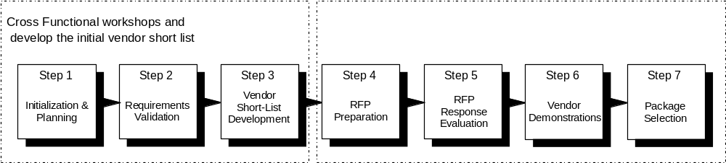

The two vendors deemed by the Katz selection team and process to best meet the requirements of this RFP will be notified on Oct 1, 2003. These two vendors will receive detailed demonstration scripts upon which they will be asked to conduct solution demonstrations between Oct 15 and Oct 23.

The tentative timetable for the proposal, evaluation and selection process is as follows:

Activity | Date (All times are EST)
RFP issued to pre-selected vendors | Sept. 3, 2003
Deadline for submitting signed Statement of Confidentiality agreement | 5:00 PM Sept. 5, 2003
Information session | 9:00 AM Sept. 12, 2003
Proposals due from vendors | 5:00 PM Sept. 24, 2003
Selection of two final vendors | Oct. 1, 2003
Demonstration scripts sent to short listed vendors | Oct. 2, 2003
First vendor demonstration | Oct.15-17, 2003
Second vendor demonstration | Oct. 21-23, 2003
Vendor customer site visits | Oct. 27-31, 2003
Notification of preferred vendor | Nov. 28, 2003

2.4 Selection Criteria

Our selection will be based primarily on the following criteria:

- Software Functionality
- Software Technology
- Total Costs
- Vendor Support (Implementation & ongoing)
- Vendor Vision / Viability
- Experience with Retail Drug industry

2.5 Confidentiality

The information in this document is strictly confidential to Katz. Vendors are requested to exercise extreme care in the distribution of this document. Dissemination of the strictly confidential information must be controlled, and distribution must be limited to the vendor's immediate organization, its agents and only those subcontractors who are needed to assist in responding to this RFP.

All responses from Katz, IBM or their representatives to vendors' questions, whether oral or written, must also be considered strictly confidential.

2.6 Acceptance of Responses

Katz reserves the right to accept or reject any or all responses, to take exception to, delete or modify these RFP guidelines, or to waive any formalities. This document is an invitation for response.

The vendor acknowledges that Katz will be relying on responses submitted by vendor pursuant to this RFP and that such responses are material to any negotiations which may result from this RFP or any contract which may be awarded pursuant to this RFP. Vendor covenants that all such responses will be complete and accurate in all material respects.

2.7 Preparation Cost

Katz is not liable for any costs incurred by any vendor prior to signing a formal contract by all parties concerned. The vendor will assume all costs incurred in providing responses to the RFP and for providing any additional information required for Katz to facilitate the evaluation process.

2.8 Attachments & Appendices Summary
An explanation of the contents of each attachment and appendix follows.

Appendix A: List of Company Locations

The list of company locations is listed to provide the vendor with a sense of the size and complexity of Katz. As evidenced within the list, Katz operates within a Canada wide retail and distribution network.

Appendix B: Present Applications Overview

The applications currently in use at Katz are identified to give a sense of which business activities are supported by application systems at Katz today.

Appendix C: Statement of Confidentiality

The confidentiality agreement to be signed and faxed back to Alan Pinington is included.

Appendix D: Key Business Processes

The high-level business processes related to merchandising and supply chain management are provided to give the vendor a sense of what Katz deems as business critical functionality.

Attachment: Functional Requirements

This attachment is an Excel Spreadsheet (Katz Requirements.xls) that contains Katz’s functional requirements. The functional requirements section of this document contains instructions on how to work with this document. Vendors are to perform a self assessment utilizing this spreadsheet.

3.0 Vendor Information

3.1 General Vendor Details

Please complete the following for each vendor contributing to your proposed solution (cut and paste the sections and change the headings for multiple vendors).

3.1.1 Proposal Contact Information

Descriptor | Response
Name
Address
Phone Number
Fax Number
Email Address

3.1.2 Head Office Information

Descriptor | Response
Address
Phone Number
Fax Number

3.1.3 Vendor Employee Profile

Descriptor | Number of Employees
Total Global
Total Canada
Total United States
R&D
Development
Product Support
Marketing
Sales
Tech. Pre Sales
Administration
Other

3.1.4 Company History

Please provide a brief history of your company. What is your company’s number of years of established business presence in Canada and in total? Please list the countries that your company has an office in and is capable of providing technical support.

3.1.5 Client Install Base

Please provide the number of live installations in Canada and in total. Also provide the number of live installations in the Retail Drug industry in Canada and in total.

3.1.6 Company Financials

Please provide audited company financials for the past three years and a published Credit or Dun & Bradstreet rating for your company. Include any other financial information to indicate financial health of your company.

3.1.7 Litigation

Please describe any pending or past litigation that you have been involved with during the last 5 years.

3.1.8 Differentiation

Please explain what differentiates you from your competitors specifically in the Retail Drug industry.

3.2 Similar Industry References

Please provide three (3) relevant examples of previous installations in the retail industry (i.e., similar size, similar process, similar suite of modules, etc.) preferably in the Retail Drug sector.

Please note: These organizations will not be contacted at this time without prior consent from the vendor. However, short listed vendors will be required to coordinate site visits with one or more customers whom have successfully implemented your solution.

3.2.1 Customer Reference #1

Descriptor | Response
Organization Name
Head Office Address
Brief Description of Organization
How is the customer similar to Katz
Number of Users Supported
Version of Software Currently Running
Modules Implemented
Countries Supported / Global
Implementation Duration
Other integrated / interfaced applications
Go Live Date
Hardware and OS Platform Being Used
Database Platform Being Used
Approx Total Cost of Implementation

3.2.2 Customer Reference #2

Descriptor | Response
Organization Name
Head Office Address
Brief Description of Organization
How is the customer similar to Katz
Number of Users Supported
Version of Software Currently Running
Modules Implemented
Countries Supported / Global
Implementation Duration
Other integrated / interfaced applications
Go Live Date
Hardware and OS Platform Being Used
Database Platform Being Used
Approx Total Cost of Implementation

3.2.3 Customer Reference #3

Descriptor | Response
Organization Name
Head Office Address
Brief Description of Organization
How is the customer similar to Katz
Number of Users Supported
Version of Software Currently Running
Modules Implemented
Countries Supported / Global
Implementation Duration
Other integrated / interfaced applications
Go Live Date
Hardware and OS Platform Being Used
Database Platform Being Used
Approx Total Cost of Implementation

3.3 Product Information

3.3.1 Product Version Information

Please provide the following details for your proposed product. If a combination of products is proposed, please provide details for each product.

Descriptor | Response
Product Name
Version
Current Version #
Date Released
Next Release Date
Programming Language
Operating Platform(s) supported
Database Management System(s) supported
Other tools required to run the application (e.g. developers’ toolkit, query tools, administrator tools, runtime licenses)
Next Release Date
Service Pack # on Current Version

3.3.2 Product Integration

Please describe the integration capability of your solution with external applications. What features of your solution make it a good fit in a multi-application environment?

3.3.3 Language Support

Please list the languages supported by your software package.

3.3.4 Currency Support

Please list the currencies supported by your software package.

3.3.5 Localization

Has your software package been localized to meet Canadian specific requirements? Describe these localizations (i.e. taxes, government regulations).

3.3.6 Concurrent Users

What is the maximum number of concurrent users by role?

3.3.7 Acquisition Information

If applicable, please describe the components contained in the proposed solution that resulted from an acquisition. Please include the date that the product was integrated into the solution and the method employed.

3.3.8 Research & Development

Explain your organization’s commitment to investing in R&D to continuously improve the product and stay on top of developments in the marketplace. How much is spent on Research and Development annually in advancing the solution/application/system?

3.3.9 Product Documentation

List the product documentation that is provided.

3.3.10 Industry Focus

Please specify commitments or focus your company has placed / undertaken on or in Retail Drug industry.

What vertical markets does your company participate in and what is the percentage of revenue generated from each?

Market | % Revenue

3.4 Implementation Considerations

It is Katz’s intention to begin the implementation process for the retail supply chain system selected as part of this process commencing December 2003.

3.4.1 Implementation Methodology

Please provide a detailed description of your preferred implementation methodology. Take our functional requirements (Katz requirements.xls) and planned business releases (Appendix D) into consideration. Break it down by module and include time estimates to complete each business release.

3.4.2 Software Upgrade Methodology

Please specify your software upgrade methodology for patches and version releases.

3.4.3 Implementation Timeframe

Based on your experience, what would be a realistic timeframe for implementation, by module or major system and by total duration? The estimate can be provided in terms of a range (e.g., 2-3 months).

3.4.4 Implementation Resources

Based on your experience in similar implementations, what types of customer resources would be required to ensure that the implementation was successful?

Phase | Resource Type | Qty | Level of Effort
 | Example: Project Manager | 1 | Full Time

3.4.5 Training

Based on your experience in similar implementations, what type of training investment is required by Katz to successfully implement your product? Please identify the type of training that is available and recommended.

Module / System | Type of Training | Duration of Training Required | Recommended Participants | Cost per participant | Location of Training

3.5 Product Support

3.5.1 Support Services

Please describe the support services you provide. Within the description please reference 24* 365 capabilities and the average / min / max wait times for each type of support service (phone, web, etc.).

3.5.2 Past Version Support

Please describe your support policy for older versions of your software. The description should reference on-going technical support, application patches and service packs.

3.5.3 Support Locations

Please provide a list of support locations.

Location (include hours of operation) | Number of Employees

3.5.4 Holidays

Please describe your policy on continuing support during local holidays and Canadian holidays.

3.5.5 Escalation Procedures

Please describe your support escalation procedures.

3.5.6 User Groups

Please provide a list of locations and contact names for any user groups.

Location | Contact Name

4.0 Product Technology

4.1 Technical Environment

4.1.1 Hardware Architecture

Please provide diagrams and narrative (including products used) that detail the Hardware Architecture that best suits your proposed solution.

4.1.2 Hardware Requirements

Based on the parameters we have provided, please complete the following for each potential hardware platform alternative providing both the minimal and optimal hardware requirements. Take into consideration a transaction volume growth of 15% annually.

Descriptor | Minimal | Optimal
Database Servers
Application Servers
Desktop Requirement
Network Requirements
Other

4.1.3 Hardware Vendor and Product

Please indicate which Hardware Vendors and Products you support and what percentage each Hardware Vendor and Product represents of your total installed base.

Hardware Vendor and Product | Percentage
Desktop System
Application Servers
Database Server

4.1.4 Hardware Performance

For each type of server (application, database, web, reporting etc) when system performance is an issue (slow response), what is the preferred method of resolving this? Is it to scale-out (i.e., add new servers) or to scale-up (i.e., to increase components within existing servers such as processors and memory)? At what point does scaling-up stop becoming effective?

4.1.5 Software Architecture

Please provide diagrams and narrative (including tools and products used) that detail the Software Architecture that your proposed solution was designed / built on.

4.1.6 Operating Systems

Please indicate which operating systems and versions you support and what percentage each operating system and version represents of your total installed base. Include all alternatives.

Operating System / Version | Percentage
Client Operating System
Application Servers
Database Server

4.1.7 Database Management Systems

Please indicate which database management systems and versions you support and what percentage each database management system and version represents of your total installed base. Include all client and host requirements and alternatives.

Database Management System / Version | Percentage

4.1.8 Data Architecture

Please provide diagrams and narrative (including tools and products used) that detail the Data Architecture that your proposed solution employs.

4.1.9 Entity Relationship Diagram

Please provide an Entity Relationship Diagram that models your proposed solutions Database. If your response is in electronic form please indicate which tool it was developed in.

4.1.10 Database Connectivity

Describe database and application connectivity or middleware requirements both for the application server(s) to connect to the database server(s) and the client application to connect to the database server(s). Include protocol (i.e., ODBC, JDBC) and tool (i.e., SQL/Net) if applicable.

4.1.11 Largest Installed Customer Site

Please describe the technical environment used to host your solution in your
- largest installed retail customer site and
- largest Retail Drug customer site
Your response should include WAN/LAN, Server Configurations, Distributed / Centralized Database, etc. and the number of concurrent users at the site.

4.1.12 Customizations/Configurations not Affecting Source Code

Please describe the ability to customize screens for user preferences and/or security needs with specific reference to how customizations affect new Service Packs and Version Upgrades.

4.1.13 Customization of Source Code

Please describe the ability to customize source code with specific reference to how customizations affect new Service Packs and Version Upgrades.

4.1.14 Data Loads

Please describe how data is initially loaded into the system during implementation and ongoing activities. For example, new module, new application, etc.

4.1.15 Client

Does your solution/application/system deploy with a thick-client? (code installed on a workstation). If so, is the thick-client optional? If a thin client (web browser based) is also available, detail the functional differences between the two client versions? Under what circumstances would the thick-client be deployed versus the thin-client?

4.1.16 Workflow

Describe the workflow processes that are available with your solution / application / system. What tools are used to implement the workflow process? How is the client notified that they have a task to perform and how is that task “delivered” to them? How many levels of approval are available?

4.1.17 Disaster Recovery

Please provide any details you may have regarding available disaster recovery services. These may be provided by yourself or a certified partner.

4.1.18 Transaction Recovery

Please provide any details you may have regarding available transaction recovery capabilities, i.e. rollback to point of failure, redundancy etc.

4.1.19 Infrastructure Changes

Please describe any issues with changing any infrastructure components (hardware, software, database sizes, etc.)

4.1.20 Web Enablement Capabilities

What portal solutions (vendors and product version) do you/have you integrated with? Please describe any issues concerning the ability of any component within the proposed solution to support supply chain transactions and sharing of planning information with suppliers.

4.1.21 Security Architecture

Please provide diagrams and narrative (including tools and products used) that detail the Security Architecture that your proposed solution employs. Describe how the solution/application/system structures users so that a user has access to see only what they are allowed to see and change only what they are allowed to change.

4.1.22 Auditing

Describe what system auditing features and reports are available for your application and provide examples where available. Does the auditing capability cover both application data as well as application configuration and security?

4.1.23 Upgrades

Describe the process of upgrading from one minor version to the next. Describe the process of upgrading from one major version to the next. When upgrading, can a company skip major or minor releases, or is the only upgrade path from the previously generally available version? Comment on database server(s), application server(s) and client desktops.

4.2 Integration and Interfaces

4.2.1 Integration Capabilities

Please describe any known issues concerning the ability of any component within the proposed solution to handle integration with other applications.

4.2.2 Financial System Interface

Describe how your application would interface with JD Edwards Financials or other Tier 1 financial package.

4.2.3 Point of Sale System Interface

Describe how your application would interface with AutoStar POS system.

4.2.4 Dispensary System Interface

Describe how your application would interface with Nexxsys Dispensary system.

4.2.5 Application Programming Interfaces

List and describe what Application Programming Interfaces (APIs) or Import / Export Managers are available with your solution / application / system to put data into the database and retrieve data.

4.2.6 Third Party Integration

Does your application come bundled with, or is friendly to 3rd party integration products? Examples of these may include a broker such as Websphere MQ Integration Broker, transformation tools such as a XML parser, or middleware such as Websphere MQ.

4.2.7 XML

If your application makes use of XML within its integration strategy, does it make use of XML standard content offered by an recognized standards organization. For example, Open Application Group (OAG).

4.3 Product Limitations

4.3.1 Product Limitation Information
Please indicate any limitations that are built into your proposed solution.

Descriptor | Answer
Number of Concurrent Users
Database Size
Number of CPU
Number of App. Servers
Company Usage (Parent / Sibling)
Other

4.3.2 Product Instances Limitations

Please describe any limitations that exist within your proposed solution in regards to the number of instances. Instances may be kept on the same server or separate servers. Please be specific in regards to technical (e.g. one database server), application (e.g. all instances must have the same date) and licensing limitations. Include limitations for multiple environments (i.e. Development, Test, Training, Production).

4.3.3 Known Coexistence Limitations

Please provide a list of all known products that your proposed solution has experienced difficulties with coexisting on the same network. Your response should include a brief description of the product and the recommended remedy.

4.4 Management Tools

4.4.1 Configuration Management Tools

Please describe any configuration management tools that are available for your system. Your response should indicate which elements (application, security, other) the tool supports, any additional costs for the tool and the developer of the tool.

4.4.2 Application Performance Management Tools

Please describe any application performance management tools that are available for your system, including monitoring, triggers, alerts. Your response should indicate which systems components the tool measures, any additional costs for the tool, and the developer of the tool.

4.4.3 Application Version Management Tools

Please describe any application version management tools that are available for your system. Your response should indicate if there are any additional costs for the tool and the developer of the tool. If there are no version management tools please describe the recommended version management approach.

5.0 Product and Service Costs

5.1 Agreements

5.1.1 Standard Purchase Contract

Please include a copy of your standard purchase contract (attach hard copy document if necessary).

5.1.2 Standard Maintenance Agreement

Please include a copy of your standard maintenance agreements (attach hard copy document if necessary).

5.2 Product Costs

5.2.1 Software Costs

Identify the software costs for your proposed solution. Please describe how these costs are calculated based on the following as applicable:
- enterprise license
- concurrent user vs. named user
- acquisition of additional user licenses
- items included with the cost (database licenses, report writers, etc.)
- items excluded from the cost (including sublicenses if applicable)
- maintenance / support
- training vouchers (based on purchase price)
- discounting criteria
- upgrade vs. maintenance
- types of license (full use, single module, inquiry, based on sales volume, enterprise, etc.) and scalability of licenses

5.2.2 Education Information Costs

Please complete the following form indicating the typical education / training requirements, given a company’s size and complexity.

Type of Training / Education | Number Days | Cost / Day
Functional Application
Technical
Database
System Architecture
System Administration
System Operational
Developer

5.2.3 Implementation Costs

Identify typical implementation costs as a multiple of software costs.

5.2.4 Hardware Costs

Identify typical hardware costs based on the hardware requirements specified in section 4.1.2.

5.3 Options

5.3. Application Service Provider Option

Please provide details on any Application Service Provider services that are available to support your solution.

5.3.3 Escrow Arrangements

Please describe the standard escrow arrangements that you provide for the application source code in your proposed solution. Be sure to include all vendor products and any costs associated with these arrangements.

6.0 Functional Requirements

6.1 Retail Supply Chain Management Requirements

Please complete the detailed functional requirements that are contained in the attached file “Katz Requirements.xls”. The rating must be completed for each and every requirement using the following legend:

9 | The vendor’s software fully satisfies the requirement as understood by the vendor.
8 | The vendor’s software will meet the requester’s requirement within 3 months, but can be demonstrated at this time.
7 | The vendor’s software will meet the requester’s requirement through workarounds. That is, alternative programmed and manual procedures.
6 | Minor reporting changes to meet requirement.
5 | Minor program modifications to meet requirement.
1 | No functionality currently exists.

6.2 Additional Systems Capabilities

Please comment briefly on your ability to provide functionality not specified in the requirements described in this RFP. (e.g. data collection, customer data confidentiality, warehouse management, etc)

Appendices

Appendix A: Katz Store Map and Head Office Locations

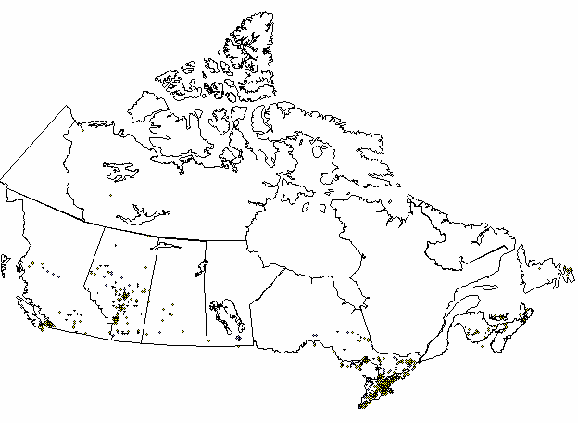

This map shows both Katz corporate and independent store locations in Canada. Currently, there are no stores in the province of Quebec.

Head Office Locations

Katz Group Canada Ltd.
5965 Coopers Avenue
Mississauga, ON
L6Z 4R9

The Katz Group
#1702 Bell Tower
10104-103rd Avenue
Edmonton, AB
T5J 0H8

Drug Trading Company Ltd.
131 McNabb Street
Markham ON
L3R 5V7

Appendix B: Present Application Systems Overview

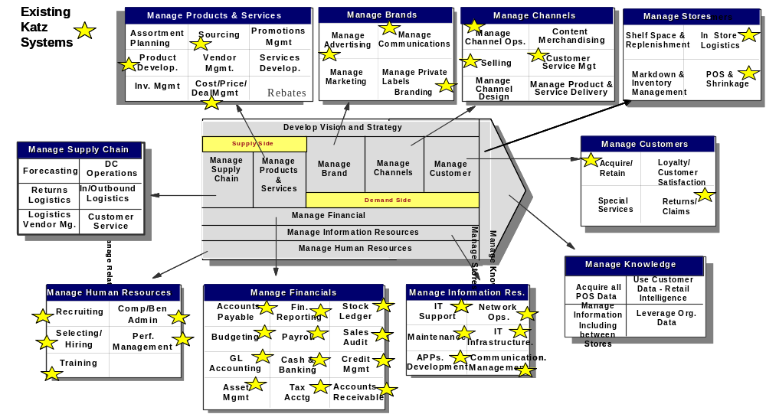

Appendix C: Statement of Confidentiality

Confidentiality
The vendor shall not disclose to anyone, other than the vendor’s employees, officers and advisors directly connected with responding to this RFP who have a need to know information which it contains, or any information concerning this RFP. Vendor shall ensure that such employees, officers and advisors are aware of the confidential nature of such information and that they have agreed to maintain the confidentiality of such information prior to disclosure. No news release, public announcement, or any other reference to this RFP or any phase of any program hereunder shall be made without the prior written consent of Katz Group Canada Limited. Vendor acknowledges and agrees that if, as a result of Vendor’s response to this RFP, additional information is disclosed to vendor by Katz Group Canada Limited or its affiliates, Katz Group Canada Limited may require the execution of a Confidentiality Agreement in form and substance satisfactory to Katz Group Canada Limited acting reasonably.

Proprietary Data
Any and all proprietary data and confidential information contained within this RFP shall be safeguarded with the same degree of protection the vendor exercises with respect to the protection of its own proprietary data and most confidential information.

Reservations
Issuance of this RFP does not commit Katz Group Canada Limited to pay any costs incurred in the preparation and submission of a response, or to procure a contract for any services, software, or equipment.

Reliance on Responses
Vendor acknowledges that Katz Group Canada Limited will be relying on responses submitted by vendor pursuant to this RFP and that such responses are material to any negotiations which may result from this RFP or any contract which may be awarded pursuant to this RFP. Vendor covenants that all such responses will be complete and accurate in all material respects.

Acknowledgment of Confidentiality
(To be returned upon receipt of the attached document)

Name of vendor : ________________________________________

Signed by : _____________________________________________

Title: _____________________________ Date: ____

Appendix D: Key Business Capabilities & Probable Business Releases

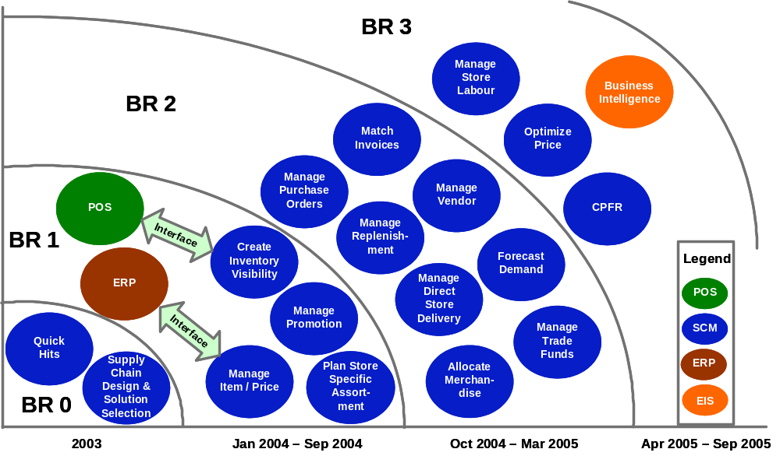

Appendix D: To-Be Process Maps Based on Leading Practices

Strategic Planning & Analysis Process Map

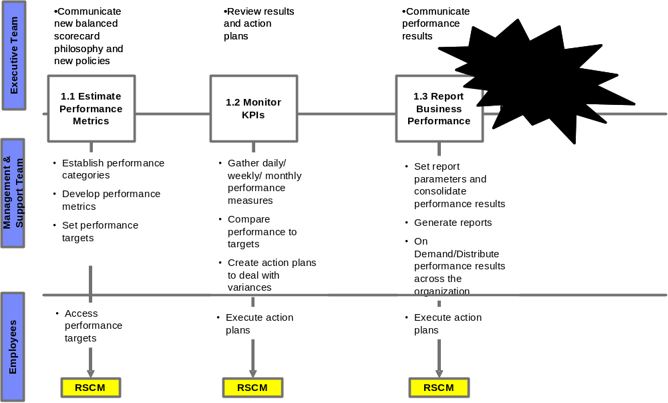

Merchandise Planning Process Map
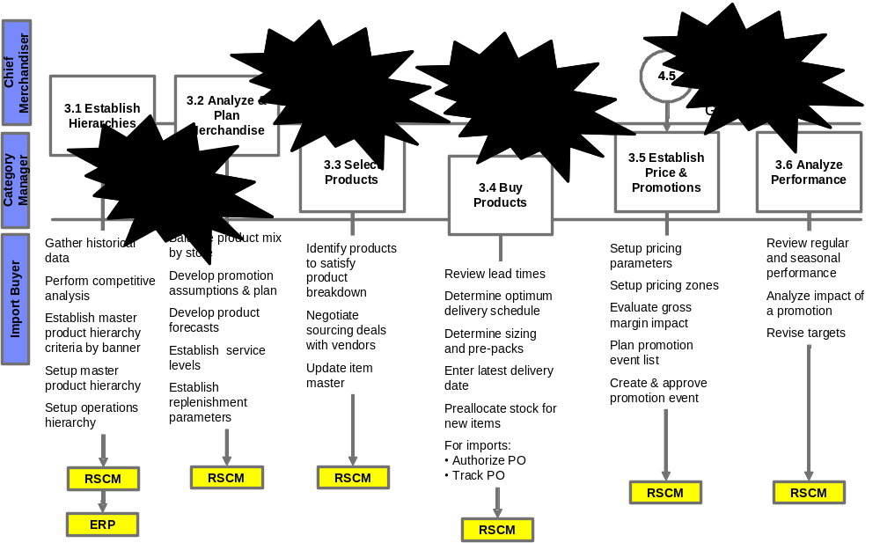
Planning & Distribution Process Map
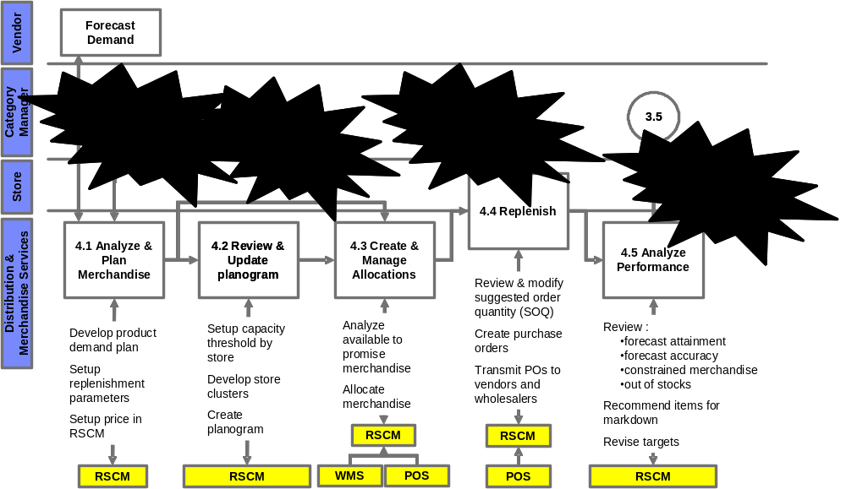
Manage Suppliers Process Map

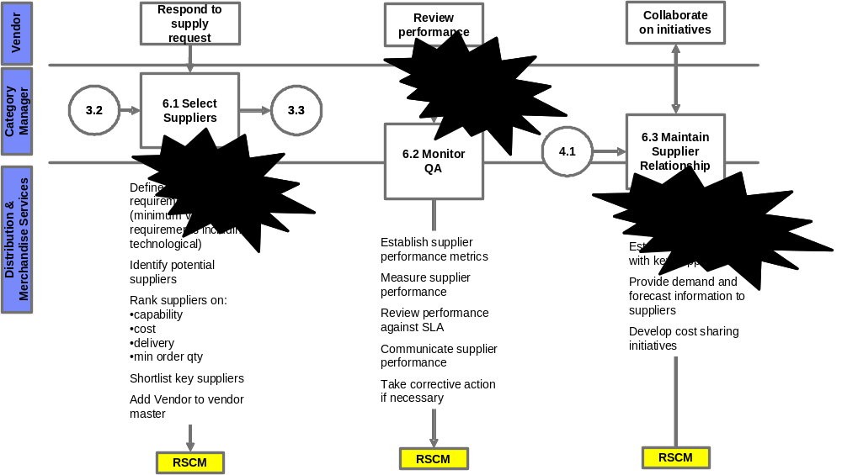
Manage Store Operations Process Map
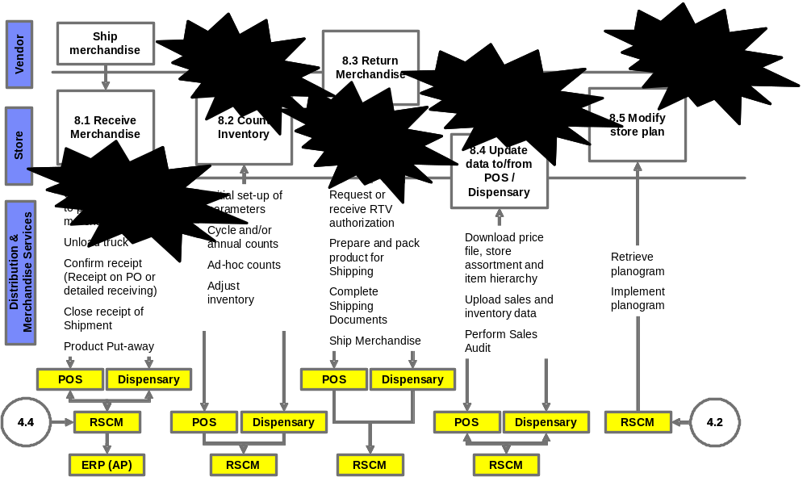

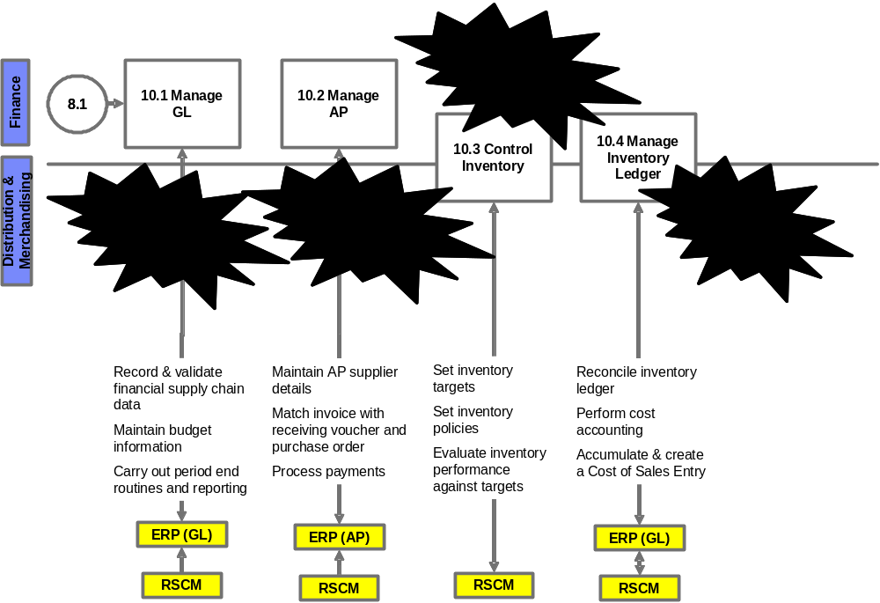
Supply Chain Finance Process Map

